SIERRA NEVADA RETRIEVER CLUB

MEMBERSHIP

JANUARY 1, 2024 - DECEMBER 31, 2024

Individual Membership $20 (1 vote)

Household Membership $30 (2
votes)

PLEASE PRINT

Name:

Name:

Mailing Address:

City & State: Zip:

Home Phone: Work Phone:

Email Address:

Renewal: New Member: (Referred by):

Dogs: How many? Breed(s)?

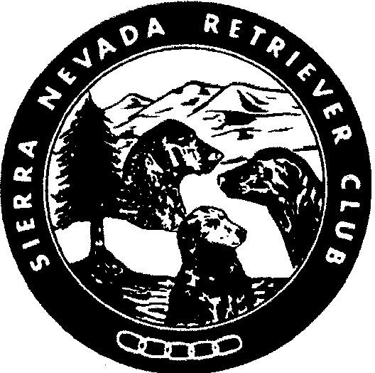
Make Check Payable to: SNRC Mail to: SIERRA NEVADA
RETRIEVER CLUB (SNRC)
Jennifer Dutton
257 Gordon Ln.
Dayton, Nv 89403

